AGV with maximum efficiency and availability

At LogiMAT 2026, Melkus Mechatronic will be showcasing revolutionary AGV developments. Austrian AGV manufacturer Melkus Mechatronic combines several strengths, including its extensive vehicle fleet, an inductive charging concept for maximum availability, minimal maintenance requirements for its systems and an independent corporate background. At LogiMAT 2026, Melkus Mechatronic will present the G130 3.0 pallet transporter for the first time, featuring optimised battery capacity for even higher performance.

Goeming/Salzburg, 15.01.2026 – LogiMAT is the most important trade show for intralogistics, and Melkus Mechatronic will be there as every year with its expert team. In Hall 8, at booth 8A67, the Austrian AGV manufacturer will be showcasing its extensive AGV fleet and technical innovations in detail on an enlarged stand area.

The focus is on increased efficiency and availability of the vehicles. Above all else, driverless transport vehicles, automated guided vehicles (AGV) or autonomous mobile robots (AMR) are required to carry out transport orders reliably, quickly and with as little downtime as possible. The Melkus Mechatronic AGV family comprises six types of highly efficient driverless transport vehicles that perform precisely these tasks with minimum maintenance.

All these vehicles can be viewed at the exhibition stand, some of them in live operation. This includes the Melkus BLS4060 rack stacker first unveiled at the 2025 LogiMAT This dynamic and space-saving special AGV for electronics manufacturing or precision engineering transports PCB magazines and Euroboxes in confined production environments and also handles rack operation at the pick-up and drop-off locations.

Highly efficient, omnidirectional pallet AGV

The star of this year's Melkus Mechatronic LogiMAT exhibit is the Melkus G130 3.0. This evolution of the Melkus G130 is a highly flexible pallet AGV for underrunning, lifting and transporting load carriers. The proven bestseller has already made a name for itself with its omnidirectional drive, which enables it to be used in confined spaces with a minimum turning radius. Separately arranged supply and control technology for each skid and an electronic differential gear ensure independent drive and result in high tolerance to uneven floors, while the modular design with standardised turntable drives keeps maintenance requirements particularly low.

The Melkus G130 3.0 has a significantly higher battery capacity and a faster, inductive charging process. Fast recharging increases the proverbial high availability of Melkus AGVs. The new battery concept of the Melkus G130 3.0 will become the new Melkus Mechatronic factory standard. As part of upcoming model updates, all Melkus AGVs will gradually be converted to this new technology.

Another forward-looking feature of the Melkus G130 3.0 is its genuine 360° panoramic view, provided by two overlapping sensors. This not only ensures optimised personal safety significantly exceeding regulatory requirements, but also enables omnidirectional driving at full speed, thereby contributing significantly to a further increase in transport performance.

“With the new battery and charging concept, we are increasing the availability of our Melkus G130 3.0 pallet AGV by up to 80 percent,” explains Martin Lindner, CEO of Melkus Mechatronic. “The upgrade to the sensor technology for true 360° all-round visibility improves both safety and efficiency.”

The innovations from Melkus Mechatronic will be on display at LogiMAT, Hall 8, booth 8A67, from 24 to 26 March 2026 in Stuttgart.

Image Captions

Melkus Mechatronic will be exhibiting at this year's LogiMAT with a larger booth and is presenting pioneering innovations in Hall 8, booth 8A67. | 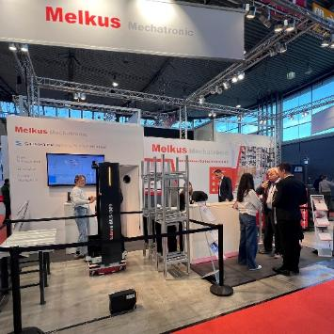
The main innovation is the Melkus G130 3.0, a power AGV with an improved battery and charging concept and genuine 360° all-round visibility thanks to LIDAR sensors.  All images, unless otherwise stated: Melkus Mechatronic. | 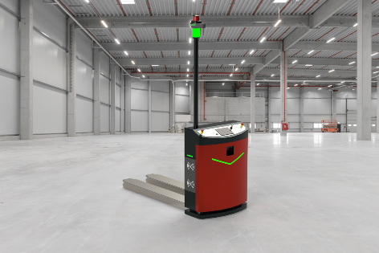
Martin Lindner, CEO of Melkus Mechatronic:  “With the new battery and charging concept, we are increasing the availability of our Melkus G130 3.0 pallet AGV by up to 80 percent. The upgrade to the sensor technology for true 360° all-round visibility improves both safety and efficiency.” | 

About Melkus Mechatronic
Melkus Mechatronic GmbH is an innovative technology company based in Salzburg. With more than ten years of experience in the field of AGVs and mobile robotics, it provides customers with highly available AGVs for flexible in-house transport with maximum reliability. Swiftly installed and commissioned, these enable Melkus operators to organise their intralogistics more efficiently and to establish resource-saving processes. Melkus employs highly qualified and committed staff and offers a range of six AGVs for a wide variety of applications. www.melkus-mechatronic.com

